
Original article

Laser Shock Peening Technologies via Q-Switch Nd: YAG, 1064nm Wavelength Influences on Microhardness and Roughness Surface Characteristics of Copper Zinc Alloy
Zahra, J.M.A. Al-Timimi
Laser Physics-College of Science for Women, Babylon University, Iraq
Abstract
Laser shock peening technologies is a surface manufacturing process employed to allow beneficial residual stresses in materials that give deep and specific protection higher than other conventional metal enhancement methods. Samples were fixed from copper alloys; tablet circular and were smoothed. For explaining the chemical composition, the X-rays fluorescence was provided to delimit the elemental structure of the samples. Q- Switching Nd: YAG laser of 1064 nm wavelength was applied at various values of energy 100-360mJ and the number of laser pulses 25-100 with the pulse repetition rate 2 Hz. Microhardness of the samples was estimated with the guidance of (Vickers hardness) testing machine. Roughness test has been escorted by roughness instrument for all samples before and after laser processing in the micron range. The most outcoming results for microhardness and roughness realized with the laser energy of (360mJ) and 100 pulses, this is due to the long gradient in heat causes more further refining in a structure and more extra increment in microhardness. The association between pulse energy and roughness is proportionality due to the addition in ablation processes, which are correlated with LSP affected by the increase of pulse energy.

Key words: Pulse energy, laser shock, chemical, Nd: YAG, Q- switch

To cite this article: Zahra, J.M.A. Al-Timimi; Laser Shock Peening Technologies via Q-Switch Nd: YAG,1064nm Wavelength Influences on Microhardness and Roughness Surface Characteristics of Copper Zinc Alloy ; Iraqi Laser Scientists Journal. Vol .1, Issue 3; Pp; 29- 36. 2019.
-

Introduction
Laser-shock peening (L-SP) is one of the surfaces processing methods that can enhance the fatigue strength of metallurgic parts by creating compressive extra-stresses in a slight layer of the reformed surface, (1). During the L-SP, the surface of the assigned part is exposed to nanosecond laser pulses of high energy from (5-100) J, (2).
The interaction zone of the material with the lasering beam vaporizes and by additional absorption of laser energy, it ionizes and converts into a plasma. Newly formed plasma continues in absorbing the laser energy and creates a pressure onto the surface via transmitting shock waves into the material, (3); meantime, when the shock waves stress exceeds the yield strength, the plastics deformation results under the interaction range, (4&5). A surrounding material of the surface layer inhibits dilatation of the irradiated zone, causing compressive extra stresses, which may reach depths up-to 1mm, (6). L-SP method is an exceeding efficient; if it’s performed out in a confined characteristic, wherever the metal surface is covered by an absorbent coating and confined via a

transparent material such as water or glass, figurer; 1. An overview of experimental scientific papers up to the last years reveals that there is a benefit in studying the possibility of analyzing surface peening (SP) method in order to increase the mechanical-thermal fatigue resistance of the materials,(7&8).
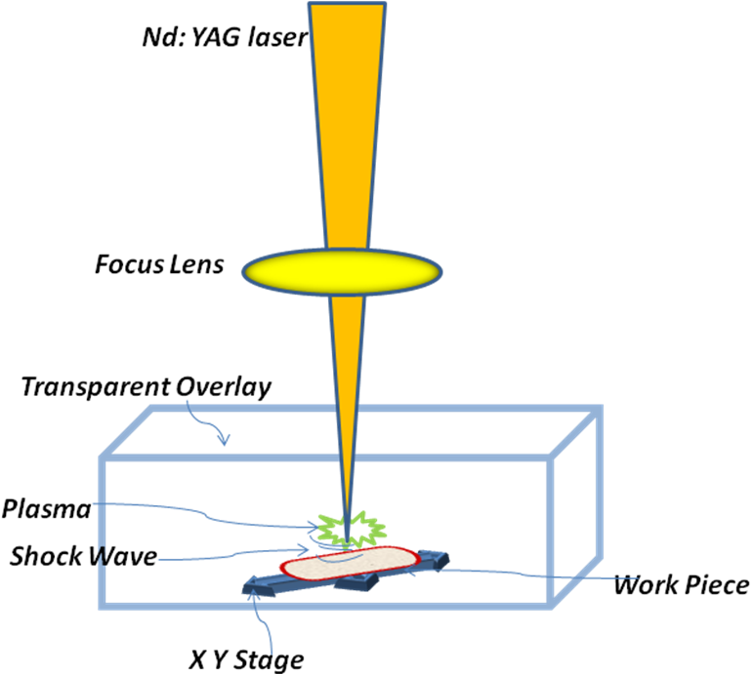

Figure.1. Schematic illustration of the L-SP method

Industrial utilization requires portions of elements that have specific surface characteristics. Brass is created of copper and zinc of differing proportions and mechanical -electrical properties to promote different varieties of brass alloys. A (Cu-Zn alloys) are additionally known as brasses are the common popular materials for those applications,(9&10). Un-alloyed copper and brass are popularly applied in the computer, communication, and consumer electronics fields because of their good electrical, thermal conductivity and malleability.
The microhardness of a surface can be developing by the L-SP. In 2012s, Sathyajith et al,(11) favorably achieved the L-SP by Nd-YAG laser, 1064nm, and low energy < 300mJ can enhance the hardness up to (20%). J. Vazquez et al.,(12) utilized the L-SP procedure to progress the hardness up to (25%). Then Janez et al., (13) examined the L-SP result at two laser energies via utilizing Vickers microhardness into depth variation in the near-surface layer.
Ordinarily, components’ with those characteristics are expensive. In this paper, laser surface processing has been applied as a cost-powerful technique to enhance the surface characteristics of brass CAS No. 63338-02-3 that can be performed by applying heat that produces by laser for the qualification of structure and enhances its physical properties. L-SP is a process for handling the materials outwardly un-changeably and any thermal impacts.
The transparent- overlay has supported in limiting the plasma extension. In this work, we have used the water. Water serves to imprison energy. L-SP is generating the plasma when its interacts with a specimen, which creates shock waves also plastic shifts of atomic extensions in the material .The expanse of this study is to explore the importance of Nd: YAG (L-SP) 1064nm, Q-switched on microhardness and surface roughness CAS No. 63338-02-3 Copper Zinc Alloy.

Materials and Methods
Preparation of the Samples
Samples were prepared from copper alloys CAS No. 63338-02-3, as a tablet circular via the diameter of (10 mm), and a thickness of (5 mm) by utilizing a turning machine. The samples were smoothed by metallographic paper and next with the diamond paste by lubricated liquid on the cloth paper followed by washing via deionizer water and ethanol before laser processing. For analyzing the chemical construction, the X-rays fluorescence was carried out to delimit the elemental structure of the samples.

Experimental Settings
A Q- Switching Nd: YAG laser of 1064nm wavelength was applied at various values of energy 100-360mJ and the number of laser pulses is ranging from 25-100 with the pulse repetition rate of 2Hz.The laser beam passes within deionizer water and approaches to the sample surface 4 mm height over the sample surface. The process was carried via managing a target sample on a holder, which was arranged onto a moving XY base.
Microhardness of the samples was estimated with the guidance of (Vickers hardness) testing machine; the measurement was made on 5N loads at the 30s for holding time. Among three measurements reading was taken and was averaged to one value needed to set a suitable microhardness profile.
Microhardness of the surface was estimated before and after laser processing. Microhardness was marked at the impact centre of the laser spot. Roughness inspection has been given with roughness -an instrument for all samples before and after L-SP.

Results
The X-Rays fluorescence technique; was utilized to analyze the chemical structure of alloy as displayed in figurer; 2. The microhardness results determined the effects of two factors on the specimens CAS No. 63338-02-3 Cu-Zn Alloy in this study; first was the effect of laser pulses energy, which we used the Vickers hardness to estimate the microhardness before and after L-SP. The medium microhardness value before laser processing around (110) HV, while after laser processing were ranged from (210-450) HV according to the laser pulse energy, figurer;3 displays the relation within microhardness and the pulse energy, which can show the increasing in microhardness from (110HV up to 520HV) after L-SP. This is because of the pressure that provides the plasma on surfaces enhanced microhardness when laser pulse energy increased. This achievement coincides with, (14&15).Second factor expected due to rising of laser pulses number. Consequently, the microhardness increases essentially, this result agrees with references, (16&17).
The roughness of the surface was estimated before and after L-SP. L-SP was arranged with 75 pulses and the pulse repetition rate was (2Hz). The measures for samples after L-SP were ranged of (0.21μm-1.043μm) while the average value of roughness before L-SP was (0.161μm).This perception is pointed to an ablation process, which is correlated with L-SP, (18). The relatiom between roughness and the laser pulse energy is shown in figurer;4.
L-SP was produced also via laser pulse energy 290mJ and the pulse repetition rate was 2Hz. An increasing of laser pulse numbers indicated a growing of microhardness and roughness as given in figure; 5 and 6. This outcome confirms the reason for growing ablation process with the increase of laser pulses number where the value of microhardness was rising from (110-520 HV), and the roughness values were improved from (0.8μm-2.94um) in a number range pulses from zero to100 pulses.
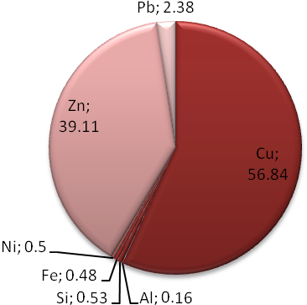
Figure.2.Chemical Composition of CAS No. 63338-02-3 Cu-Zn Alloy

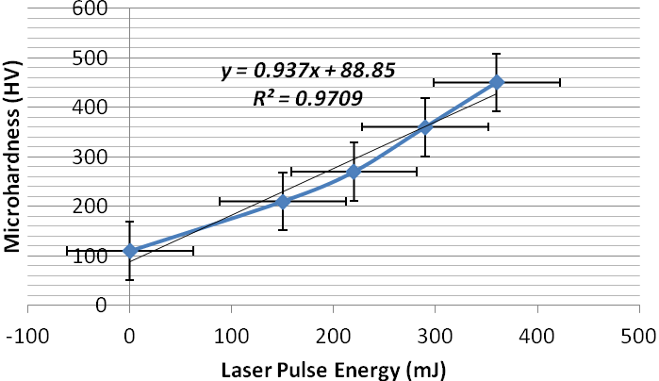
Figure.3.The outcomes of laser pulses energy and a microhardness.

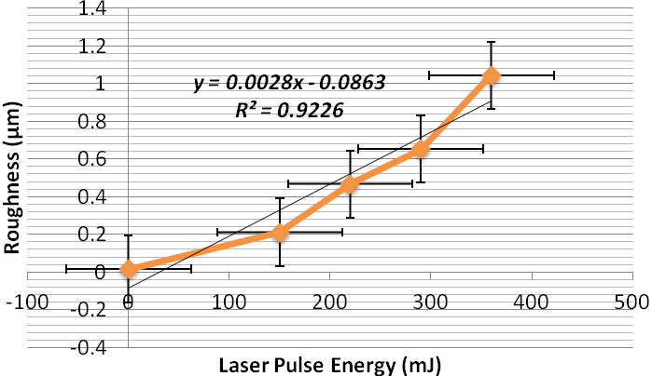
Figure.4.The outcomes of roughness and laser pulse energy
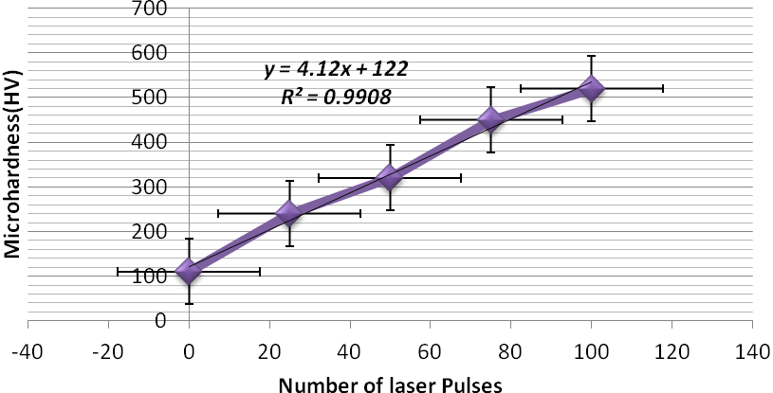
Figure.5.The influence of the number of the pulses of laser on the microhardness

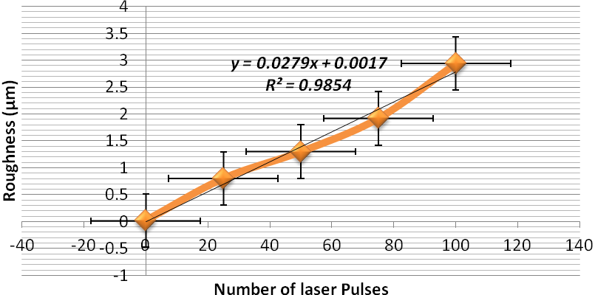

Figure.6.The impact of the number of the pulses of laser on the roughness

Discussion
Hardness characteristics influences of the L-SP are estimated based on a microhardness analysis that can be taken by using the Vickers microhardness test, which is usually more ordinary than other tests because the calculations are independent of the size of the sample. A fundamental principle of microhardness and roughness measurements is to recognize the material's ability to resist plastic deformation from the standard source, (19&20).
In this study, for all depth point, an average value for three measurements has been calculated. The standard deviations of the samples have been included in the figures as an error bar. It can be remarked that the microhardness and roughness of the surface raises linearly with laser energy. These differences of the microhardness and roughness are due to the shock waves, which are formed via the expansion of high-pressure plasma-induced via a pulsed laser,(21&22).
It is obvious that the microhardness and roughness of materials improves as the number of pulses boosts. Moreover, the magnitude of the microhardness and roughness produced from Nd: YAG, 1064nm is more extended than that from Nd: YAG, 532nm, (23&24).
The expansion of the magnitude of the microhardness and roughness is scheduled to the impact of the extraordinary intensities of the laser ablation by pulsed laser includes nanosecond and microsecond, that leads to evaporation, melting, and plasma formation,(25); Then, the shock waves are created and the microhardness is enhanced, (26). Consequently, the plasma formation and ablation are progressed by raising the number of laser pulses, (27). This study gives a high-minded potential solution to improve the assurance of components and sensitivity decreasing to damage.

Conclusions
The influences of L-SP on the mechanical surface characteristics of CAS No. 63338-02-3 Cu-Zn Alloy were investigated. Specimens were exposed to L-SP using various laser pulses densities, and a different number of pulses. The examined surface properties were roughness and microhardness. In accordance with our study, the following determinations were verified:
- The most becoming result for microhardness and roughness realized with laser energy of 360mJ and pulses number of 100, due to the long gradient in heat, which causes further refining in a

structure and more extra increment in microhardness.
- The increase of surface roughness is an outgrowth of the mixed influence of the laser pulses pressure and the ablative process of the L-PS.
- The association between pulse energy and roughness is characteristic due to the ablation processes that are related to L-SP, which increase, by pulses energy.

The performed surface results show that a combination of compressive microhardness and comparatively low roughness of the surfaces can be accomplished with the suitable L-SP processing parameters. Furthermore, these surfaces characteristics may be advantageous for fatigue resistance, while other important determinants have to be taken into accounts, like thickness and the distance of edges of the L-SP administered area. In order to authenticate a profitable influence of L-SP on mechanical properties of Cu-Zn Alloy, fatigue testing should be accompanied in forthcoming researches.

Refrences
- Kalentics, N., Boillat, E., Peyre, P., Gorny, C., Kenel, C., Leinenbach, C & Logé, R. E. (2017). 3D Laser Shock Peening - A new method for the 3D control of residual stresses in Selective Laser Melting. Materials & Design, 130, 350-356.‏
- Zhang, X.C.,Y. K., Lu, J. Z., Xuan, F. Z., Wang, Z. D., & Tu, S. T. (2010). Improvement of fatigue life of Ti–6Al–4V alloy by laser shock peening. Materials Science and Engineering: A, 527(15), 3411-3415.‏
- Kalentics, N. Boillat, E., Peyre, P, Ćirić-Kostić, S., Bogojević, N. & Logé, R. E.(2017). Tailoring residual stress profile of selective laser melted parts by laser shock peening. Additive Manufacturing, 16, 90-97.‏
- Rubio-González,,Felix-Martinez,Gomez-Rosas, G., Ocaña, J. L., Morales, M & Porro, J. A. (2011). Effect of laser shock processing on fatigue crack growth of duplex stainless steel. Materials Science and Engineering: A, 528(3), 914-919.‏
- Diam, W. A., & Zahra, A. T. (2019). Characterization and fabrication of Nd: YVO4 disc laser system. In AIP Conference Proceedings (Vol. 2123, No. 1, p. 020009). AIP Publishing LLC.‏
- Luo,S.,He,W.,Chen, K., Nie, X., Zhou,& Li, Y.(2018). Regain the fatigue strength of laser additive manufactured Ti alloy via laser shock peening. Journal of Alloys and Compounds, 750, 626-635.‏
- Brockman,R.A.,Braisted,W.R.,Olson, S. E, Tenaglia, R. D.,Clauer, A. H., Langer,& Shepard, M. J. (2012). Prediction and characterization of residual stresses from laser shock peening. International Journal of Fatigue, 36(1), 96-108.‏
- Kalentics, N. Huang, K.de Seijas,M., Burn, A.,Romano, V.,& Logé, R. E. (2019). Laser shock peening: A promising tool for tailoring metallic microstructures in selective laser melting. Journal of Materials Processing Technology, 266, 612-618.‏
- Bhamare,S.,Ramakrishnan,Mannava,Langer, K., Vasudevan, V. K., & Qian, D. (2013). Simulation-based optimization of laser shock peening process for improved bending fatigue life of Ti–6Al–2Sn–4Zr–2Mo alloy. Surface and Coatings Technology, 232, 464-474.‏
- Ye,C., Suslov, S, Lin, D., Liao, Y., Fei, X., & Cheng, G. (2011). Microstructure and mechanical properties of copper subjected to cryogenic laser shock peening. Journal of Applied Physics, 110(8), 083504.‏
- Luo, K.Y., Jing, X., Sheng, J.,Sun, G. F., Yan, Z.,& Lu, J (2016). Characterization and analyses on micro-hardness,residual stress and microstructure in laser cladding coating of 316L stainless steel subjected to massive LSP treatment. J. Alloys &Compounds, 673, 158-169
- Ren, X. D., Zhou, W. F., Liu, F. F., Ren, Y. P., Yuan, S. Q., & Yang, T. (2016). Microstructure evolution and grain refinement of Ti-6Al-4V alloy by laser shock processing. Applied Surface Science, 363, 44-49.‏
- Wei,& Ling, X. (2014).Numerical modelling of residual stress induced by laser -shock processing. Applied surface science, 301, 557-563.
- Liao,Ye,C.,& Cheng, G. J. (2016). A review: warm laser shock peening and related laser processing technique. Optics & Laser Technology, 78, 15-24.‏
- Kalainathan,S., & Prabhakaran,(2016). Recent development and future perspectives of low energy laser shock peening. Optics & Laser Technology, 81, 137-144.‏
- Sun, R., Li, L., Zhu, Y., Guo, W., Peng, P., Cong, B, & Liu. (2018). Microstructure, residual stress and tensile properties control of wire-arc additive manufactured 2319 aluminum alloy with laser shock peening. Journal of Alloys and Compounds, 747, 255-265.‏
- Zahra, J. M. A. (2019). Investigation of the semiconductor laser beam propagation through air and pure water (stable and turbulence). Iraqi Laser Scientists Journal, 1(3), 7-14.‏
- Ge, M. & Xiang, J. (2016). Effect of laser shock peening on microstructure and fatigue crack growth rate of AZ31B magnesium alloy. Journal of Alloys and Compounds, 680, 544-552.‏
- Lu, J. Z., Wu, L. J., Sun, G. F., Luo, K. Y., Zhang, Y. K., Cai, J.,& Luo, X. M. (2017).Microstructural response and grain refinement mechanism of commercially pure titanium subjected to multiple laser shock peening impacts. Acta Materialia, 127, 252-266.‏
- Di, J., Zhou, M., Li, J., Li, C., Zhang, W., & Amoako, G. (2012). Micro-punching process based on spallation delamination induced by laser driven-flyer. Applied surface science, 258(7), 2339-2343.‏
- Warren, A. W., Guo, Y. B., & Chen, S. C. (2008). Massive parallel laser shock peening: simulation, analysis, and validation. International Journal of Fatigue, 30(1), 188-197.‏
- Yang, J. M., Her, Y. C., Han, N., & Clauer, A. (2001). Laser shock peening on fatigue behavior of 2024-T3 Al alloy with fastener holes and stopholes. Materials Science and Engineering: A, 298(1-2), 296-299.‏
- Kanjer, A., Lavisse, L., Optasanu, V., Berger, P., Gorny, C., Peyre, P., ... & de Lucas, M. M. (2017). Effect of laser shock peening on the high temperature oxidation resistance of titanium. Surface and Coatings Technology, 326, 146-155.‏
- Lavisse, L., Kanjer, A., Berger, P., Optasanu, V., Gorny, C., Peyre, P., ... & de Lucas, M. M. (2020). High temperature oxidation resistance and microstructure of laser-shock peened Ti-Beta-21S. Surface and Coatings Technology, 126368.‏.
- Tan, D. Q., Mo, J. L., He, W. F., Luo, J., Zhang, Q., Zhu, M. H., & Zhou, Z. R. (2019). Suitability of laser shock peening to impact-sliding wear in different system stiffnesses. Surface and Coatings Technology, 358, 22-35.‏
- Liao, Y., Ye, C., Kim, B. J., Suslov, S., Stach, E. A., & Cheng, G. J. (2010). Nucleation of highly dense nanoscale precipitates based on warm laser shock peening. Journal of Applied Physics, 108(6), 063518.‏
- Zheng, L., Zhang, C., Zhang, C., & Dai, F. (2017). Performance of micro-dent array fabricated by laser shock peening on the surface of A304 stainless steel. Vacuum, 138, 93-100.‏

